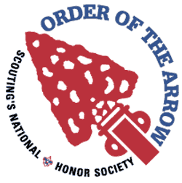

“…and that is what I pray for in the years ahead for the Arrowmen as they face the future—feeling that God will help them to do that which our country needs and do it with devotion in the brotherhood of cheerful service.” –Dr. E Urner Goodman

Lemhee-Okee Chapter
Tipisa Lodge 326

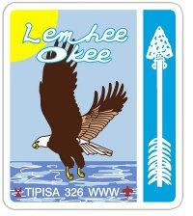

Sand Lake District
Central Florida Council

2013-2014 Chapter Planbook

And So Said The Chief
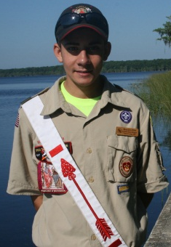

Brothers,

I can’t wait for the year ahead of us. Your chapter leadership has planned so many great things for us this year, many of which the chapter has never seen the likes of. Our goal is to be the Best All Around Chapter in Tipisa Lodge and be a Gold JTE Chapter. With lots of brotherhood, cheerfulness, and service, this is easily obtainable. I hope to induct many new brothers into our order this year and see our members, new and old alike, further their knowledge and obtain brotherhood. Maybe most important however, is that we all have lots of fun this year.

Yours in Brotherhood,
Brandon Eiler
Lemhee-Okee Chapter Chief
chief@lemheeokee.org

Notes

The OA Sash

The Order of the Arrow (OA) sash is a white fabric sash with a red arrow embroidered upon it. The sash is worn at Order of the Arrow functions and special Scouting activities, when members need to be identified as Arrowmen rendering special services. The official Order of the Arrow sash is available for members through their local lodge or local Scout Service Center, or through the Supply Division of the BSA. Each of the three levels for OA is represented by a different sash as illustrated below. The sash is worn over the right shoulder so that the arrow is pointing over the right shoulder. The sash is worn diagonally across the chest. It must not be worn in any other manner. Sashes may not be altered in any way or form. Nothing is to be worn on the sash, including signatures, patches of any kind, pins, or beads.
Ordeal 

Brotherhood 

Vigil Honor 
2013-2014 Chapter Leadership

Chief | Brandon Eiler  4074324532 | chief@lemheeokee.org
Advisor | Greg Batty  4073405235 | advisor@lemheeokee.org
Associate Advisor | Brad White  4075954902 | Scoutmaster823@aol.com
1st Vice | Kellen Cooper | 1stvicechief@lemheeokee.org
2nd Vice | Tyler Batty | 2ndvicechief@lemheeokee.org
Secretary | Jacob Neff | secretary@lemheeokee.org
Treasurer | Hunter Clifton | treasurer@lemheeokee.org
Historian | Andrew Colgan  Brennan Cooper | historian@lemheeokee.org
Activites &  Service | Jordan Walton | activitesandservice@lemhee  okee.org
American Indian | Open | americanindian@lemheeokee.org
Camping Promotion | Open | campingpromotion@lemheeokee.org
Ceremonies | Tyler Batty | ceremonies@lemheeokee.org
Inductions | Andrew Colgan | inductions@lemheeokee.org
Membership | Open | membership@lemheeokee.org
OA Troop Rep | Open | oatrooprep@lemheeokee.org
Ordeal | Jordan Walton | ordealmaster@lemheeokee.org
Publications | Brandon Eiler | publications@lemheeokee.org
Website | Brandon Eiler | website@lemheeokee.org

Our History
Lemhee-Okee Chapter
Established June 2001

A New Beginning

Chapter C was formed from the southwest portion of Chulee Afopkeh which served West Orange District and a southern portion of Econlockhatchee serving Chickasaw District. Members of the new chapter gathered at the Service Weekend for cheerful service to Camp La-No-Che. Together they cleaned up the compound area and prepared for upcoming camp inspections. All were pleased with how well everyone worked together in cheerful service. Certainly that weekend marked the beginning of great things to come for the newly established chapter.

After the lodge elections on Saturday evening, chapter elections were held with many adult and youth members in attendance who were part of the discussions for the new chapter.

When discussing a name for the new chapter, the members wanted a totem that would fit the leadership and strength of a new chapter. The chapter members chose the Eagle as their totem because of the traditional qualities associated with the great bird: leadership, patriotism, strength, and the highest rank in scouting to name a few. They also wanted to have the Eagle associated with a landmark or our community. Due to the blessing of numerous lakes in the chapter, everyone agreed that the lakes were a great asset. Rick Obermeyer provided the American Indian words, Lemhee-Okee, which means “Eagle of the Waters”. The chapter members voted to submit the name to the Supreme Chief of the Fire for his approval. Meanwhile, the district committee voted to name the district Sand Lake District.

Thus, a new beginning for the Lemhee-Okee Chapter of Sand Lake Distirct.

3. Serve in at least one of the following positions or on one of the following committees. This should be initialed by the chapter chief or advisor.

Youth Chief/Adv. Initial
Officer _____________
Chairman/Committee Member _____________
Ceremonies Team _____________
OA Grill _____________
Unit Election Team _____________
Elangomat _____________
OA Troop Representative _____________
Adult
Advisor _____________
Elangomat _____________
Provide Transportation for youth to at
least 2 events (excluding your son) _____________

4. Additional Requirements. You must complete 1 of the following.
Obtain Brotherhood membership or
convince another to obtain it. _____________
Obtain The 40 Hours of Service Award _____________
Attend a national OA event _____________
Write an article for the Limat _____________
5. Your dues are current. _____________

When you have completed the above requirements, obtain the Chapter Chief’s Signature and turn this into the secretary. You will be recognized at the Chapter Banquet and presented with an award.

Name: ________________________________________
Date Completed: ________________________________
Chapter Chief’s Signature: ________________________
Chapter Spirit Award

The Lemhee-Okee Spirit Award is an award for all Arrowmen who are active, show leadership in the chapter, and who display the characteristics of cheerfulness, service, and brotherhood. (New Ordeal Members: Your requirements apply from the date of your ordeal.)

1. Attend over half of the monthly chapter meetings. This should be initialed by the chapter secretary.

Meeting Sec. Initial Meeting Sec. Initial
August ________ January ________
September ________ February ________
October ________ March ________
November ________ April ________
December ________

2. Attend over half of the chapter and lodge events held during the year. This should be initialed by the chapter secretary.

Event Sec. Initial
LLDP & Banquet ________
Fall Fellowship ________
Webelos Woods ________
Project One Day ________
Cub Scout Weekend ________
Section Seminars ________
Call-Out Ceremony ________
Lemhee-Okee Ordeal ________
Brotherhood Day/Ceremony ________
TNAW ________
Spring Conclave ________
Section Conference ________
Service Weekend ________

Order of the Arrow Obligation

I do hereby promise on my honor as a Scout,
that I will always and faithfully observe and
preserve the traditions of the Order of the Arrow, Wimachtendienk, Wingolauchsik, Witahemui.

I will always regard the ties of brotherhood
in the Order of the Arrow as lasting, and will
seek to preserve a cheerful spirit, even
in the midst of irksome tasks and weighty
responsibilities, and will endeavor, so far as
in my power lies, to be unselfish in service
and devotion to the welfare of others.

Order of the Arrow Official Song
Words by E. Urner Goodman
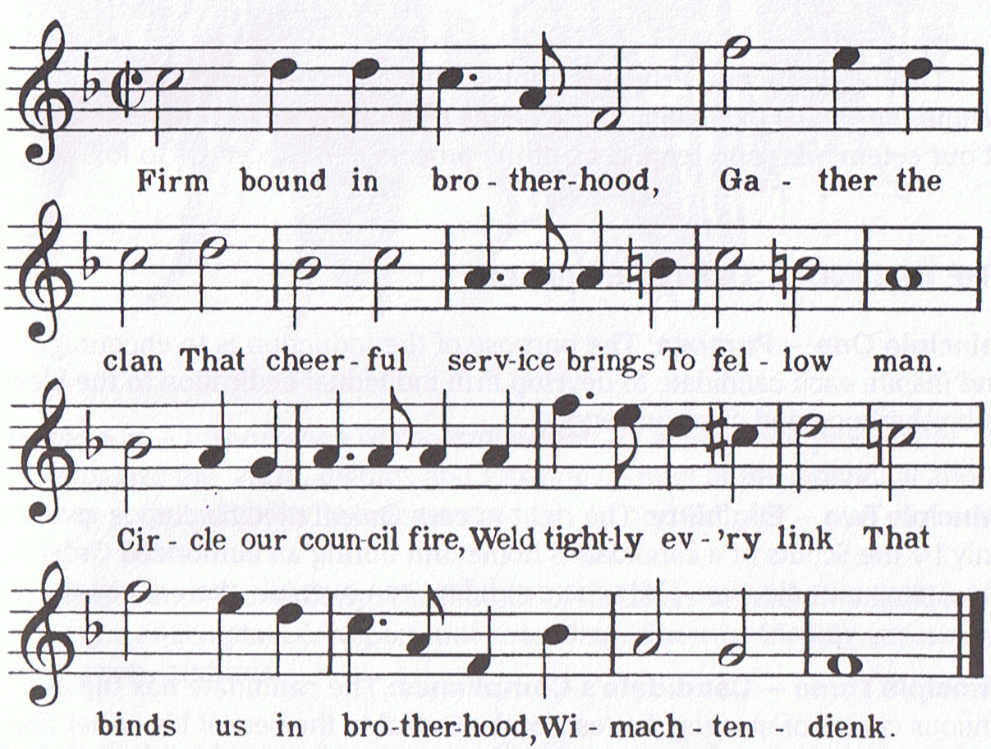
Lodge Totem
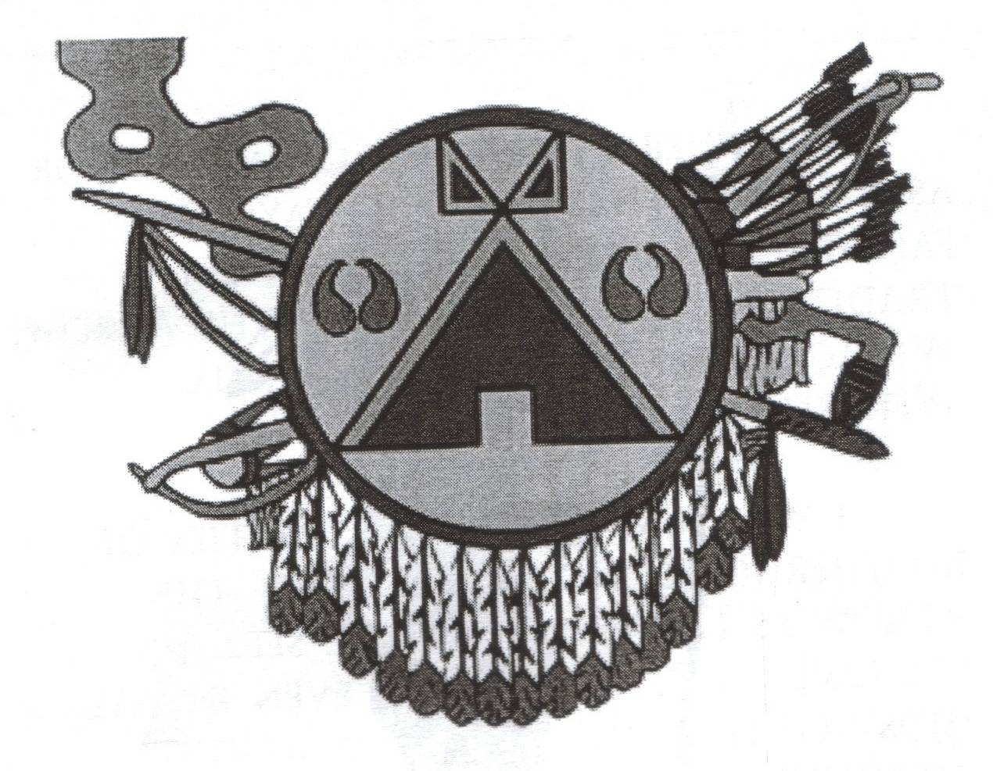
Tipisa is a Lakota word for "Red Lodge", and it was elected to use a Lakota style tipi emblazoned on a shield. A shield with its eagle feathers (Quantity varies according to the number of active chapters in the lodge) symbolizes that our lodge is the central body to which its chapters are unique, yet attached. The shield is a tool of our service to protect the heritage, traditions, and ideals of Scouting. The bison hoof prints are to remind us to remain faithful and vigilant in our protection of the environment, remembering not to waste its resources. The 12 arrows represent the 12 Scout Laws. The quiver is the Scout Oath in which these laws are to dwell. The unstrung bow
symbolizes we're prepared to defend those laws and the ideals they represent. The pipe, misunderstood by many, wasn't used for pleasure, but for welcoming friends into council, deliberation, worship, and for bestowing blessings. Tobacco was considered medicinal and sacred by all Native American peoples, and neither abused nor defiled as it is today. Its smoke carried prayers heavenward, and was used to infuse objects and ideas with prayer.
The black background represents the night alone of your Ordeal, and to those that truly serve, the Vigil they keep in recognition of their
honor. The red border is the symbolic blood we shed during our ordeal, welding tightly every link that binds us in Brotherhood.
Out of the darkness emerges the ordeal candidate as a full member of the WWW, our Brotherhood of Cheerful Service. We are servants
to Man, our communities, our nation, our world. Wear it with honor and purpose as you serve.

Check www.lemheeokee.org for information regarding meetings and other events.

You can also download The Limat, Lemhee-Okee’s award winning newsletter, from the resources section.

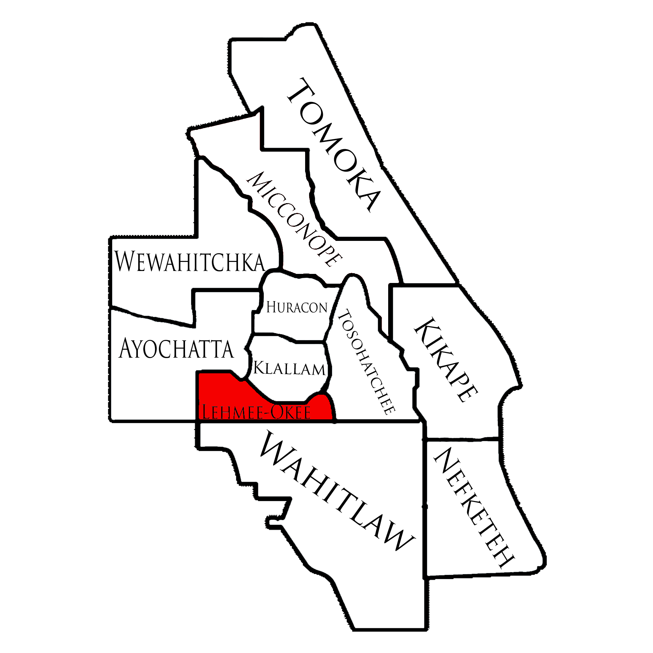

Calendar
2013-2014
Subject to change. Visit our website for updates.
August April
2nd Chapter Meeting 4th Chapter Meeting
18th LLDP & Banquet 19th-21st Section Conf.

September May
6th Chapter Meeting, 2nd Chapter Meeting
Bass Pro Shops 17th-19th Service Wknd
6th-8th Fall Fellowship

October June
4th Chapter Meeting,
Bass Pro Shops 6th Chapter Meeting
5th-7th Webelos Woods 10th-14th Cub Scout
19th-21st Cub Family Campout Day Camp
27th Project One Day

November
? Chapter Meeting
16th-18th Section Seminars

December
1st Camporee & Call-Out
6th Chapter Meeting
15th Vigil Reunion

January
3rd Chapter Meeting
4th-6th Ordeal

February
7th Chapter Meeting
8th-10th TNAW

March
7th Chapter Meeting
15th-17th Spring Conclave

New Ordeal Members

So you have completed that back breaking ordeal? What now? Well my brothers, you could hang your pretty new sash up in your closet, dash, and never be seen again at an OA function. Or, you could become an active member of our order, further your knowledge, take that knowledge back to your troop, and have lots of fun in the process.

The ordeal ceremony is deep with symbolism and meaning. There are many ways to further your knowledge. One of which is to become a ceremonialist yourself. Another is to obtain brotherhood.

Brotherhood
Seal your membership and further your knowledge of our order by completing brotherhood counseling 10 months after your ordeal. Brotherhood, however, is not a rank, as in scouting (scout, tenderfoot, 2nd class, etc.), but a level of knowledge and understanding of our order.

Chapter and Lodge Activities

LLDP: This is Tipisa’s annual training day; time is devoted to building the leadership abilities that each member of our order possesses. It is geared towards chapter leadership, but all members are welcome and will learn much about our order.

Lodge Banquet: An annual gathering to celebrate Tipisa’s accomplishments over the past year. Awards are presented such as Most Dedicated Lodge Officer, Most Dedicated Chapter Chief, Most Improved Chapter, Best All Around Chapter, The Outstanding Service Award, and many more.

Fall Fellowship: The lodge’s first fellowship weekend with training seminars and competitions in the morning. In the afternoon is the Quest for the Golden Arrow game competitions. The evening ends with a campfire program, cracker-barrel, games, and a movie.

Brotherhood Opportunities: Ordeal members who have represented the ideals of the order and served their fellow man for 10 months have the opportunity to receive brotherhood counseling and seal their membership in the ordeal.

Chapter Ordeal: During this weekend new members are inducted into the order. We also provide cheerful service to camp.

Spring Conclave: This is the second fellowship weekend. It is much like Fall Fellowship, with seminars, competitions, and games. We greet our new brothers with enthusiasm, and allow them to further their understanding of the order. The annual Vigil Honor class is also recognized at this weekend.
Chapter and Lodge Activities

Service Weekend: This Lodge weekend is full of fund and service at Camp La-No-Che which helps prepare for the thousands of campers attending Summer Camp. Lodge elections are also held this weekend.

Project One Day: Project One Day is an opportunity for every lodge in the region to do meaningful service in their communities – in one day!

Chapter Banquet: Lemhee-Okee Chapter will hold their own Chapter Banquet for the first time in their history. It will be a time to celebrate our past year’s accomplishments and present awards to our deserving arrowmen and advisors.

Chapter Awards

Chapter Spirit Award: This is an award for Arrowmen who are active, show leadership in the chapter, and who display the characteristics of cheerfulness, service, and brotherhood.

Outstanding Service Award: The Lemhee-Okee Chapter Outstanding Service Award (OSA) is the most prestigious recognition given by the chapter. There is no criteria for the award, it however is presented to members who have given substantial and outstanding service to their chapter. One youth and one adult advisor is given the award per year. The youth recipient is selected by the adult advisors and the adult advisor recipient is selected by the youth. The OSA is an award for life; it can only be earned once as a youth and once as an adult.

